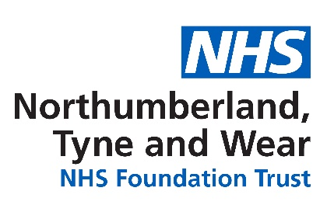

**ELIMINATING MIXED SEX ACCOMMODATION**

**DECLARATION OF COMPLIANCE 2018/19**

Northumberland, Tyne and Wear NHS Foundation Trust is pleased to confirm that we are compliant with the Government’s requirement to eliminate mixed sex accommodation, except when it is in the patient’s overall best interest, or reflects their personal choice.

We have the necessary facilities, resources and culture to ensure that patients who are admitted to our hospitals will only share the room where they sleep with members of the same sex, and same sex toilets and bathrooms will be close to their bed area.

Sharing with members of the opposite sex will only happen when clinically necessary for example where patients need specialist equipment such as in the case of hoist equipment, specialist facilities will be used by both genders, or when patients actively choose to share (for instance a mixed lounge).

If our care should fall short of the required standard, we will report it. We have set up an audit mechanism to make sure that we do not misclassify any of our reports. The results of our bi-annual audits will continue to be published on our website.

**What does this mean for patients?**

Other than in the circumstances set out above, patients admitted to Northumberland, Tyne and Wear NHS Foundation Trust can expect to find the following:-

**Same sex accommodation means:**

* The **room where your bed is** will only have patients of the same sex as you
* Your **toilet and bathroom** will be just for your gender, and will be close to your bed area

It is possible that there will be both men and women patients on the ward, but they will not share your sleeping area. You may have to cross a ward or corridor to reach your bathroom, but you will not have to walk through opposite sex areas.

You may share some communal space, such as day rooms or dining rooms, and it is very likely that you will see both men and women patients as you move around the hospital. It is probable that visitors of the opposite gender will come in to the room where your bed is, and this may include patients visiting each other.

It is almost certain that both male and female nurses, doctors and other staff will come into your bed area. If you need help to use the toilet or take a bath (e.g. you need a hoist or special bath) then you may be taken to a “unisex” bathroom used by both men and women, but a member of staff will be with you, and other patients will not be in the bathroom at the same time.

**The NHS will not turn patients away just because a “right-sex” bed is not immediately available.**

**What are our plans for the future?**

We continue to evaluate our estate in order to consider ongoing compliance and effectiveness and to identify any minor adjustments which would enable improved privacy and dignity standards to be achieved.

**How will we measure success?**

We will use a range of methods to measure the success of our delivery plan including patient and carer satisfaction surveys and routine monitoring through our contract with commissioners.

**What do I do if I think I am in mixed sex accommodation?**

We want to know about your experiences. Please contact our Complaints Team on 0191 245 6672, or via the following e-mail address: [complaints@ntw.nhs.uk](mailto:complaints@ntw.nhs.uk) if you have any comments or concerns.