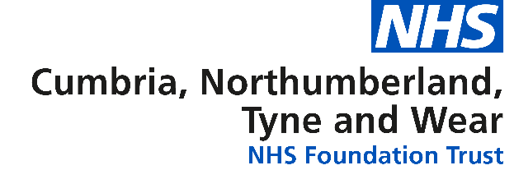

Children’s Community Speech and Language Therapy Team
into Hadrian, Sir Charles Parsons and Thomas Bewick schools in Newcastle.

Information for referrers


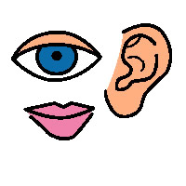

What we do
We provide intervention for children with communication difficulties and problems with eating, drinking and swallowing.
We work closely with staff and parents in a range of settings.

Referral Criteria
The child or young person must be between 3-19 years old and attending a special school in Newcastle. The staff in the schools have expertise in developing communication skills, however additional support can be provided by Speech and Language Therapy (SALT) service if required.
Young people and parent(s)/carers can self – refer to Community Team Learning Disabilities (CTLD). Referrals also come from school staff and other professionals.

We accept referrals when the child or young person:
- Has no functional communication system and requires support to explore options to develop this.
- Is developing a skill that requires specialist input such as Makaton signing, symbol based communication systems or a Voice Output Communication Aid.
- Has difficulty generalising communication skills to their school and home environment.
- Has eating, drinking and/or swallowing difficulties requiring specialist management.

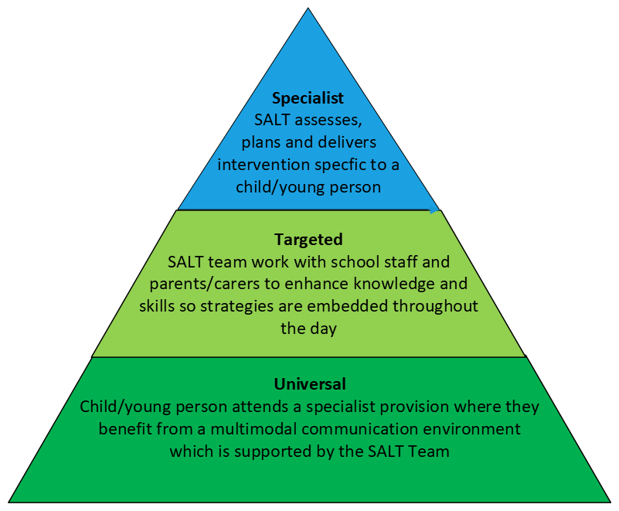
Speech and language therapists (SALT) working into the Specialist Provision in Newcastle offer support at the following levels:

A referral is needed for specialist level support and may be needed for targeted level – please discuss with the SALT team.

How to Make a Referral
- Referrals need to be made on the CTLD referral form
- The Referral form is available electronically from CTLDAdmin@cntw.nhs.uk or the SALT team in school
- Referral should be sent to CTLDAdmin@cntw.nhs.uk and password protected if sending from an outside agency

How to contact us
The Speech and Language Therapy department can be contacted on the following numbers:
Hadrian School: 0191 273 4440
Sir Charles Parsons: 0191 295 2283
Thomas Bewick: 0191 229 6020
During the school holidays contact Benton House: 0191 210 6868

What if I have a comment, suggestion, compliment or complaint about the service?
If you want to make a comment, suggestion, compliment or complaint you can:
- ask a member of staff for a feedback form, or complete a form on the Trust website www.cntw.nhs.uk (click on the ‘Contact Us’ tab)
- contact the Complaints Department Tel: 0191 245 6672 (via text Relay UK 18001) or complaints@cntw.nhs.uk
- We are always looking at ways to improve services. Your feedback allows us to monitor the quality of our services and act upon issues that you bring to our attention.

This information can be made available in a range of formats on request (eg Braille, audio, larger print, easy read, BSL or other languages). Please contact the Patient Information Centre
Tel: 0191 246 7288 (via text Relay UK 18001)

Published by the Marketing Department,
2023 Copyright, Cumbria, Northumberland, Tyne and Wear NHS Foundation Trust
www.cntw.nhs.uk
Switchboard Tel: 0191 246 6800
Review date: April 2025

