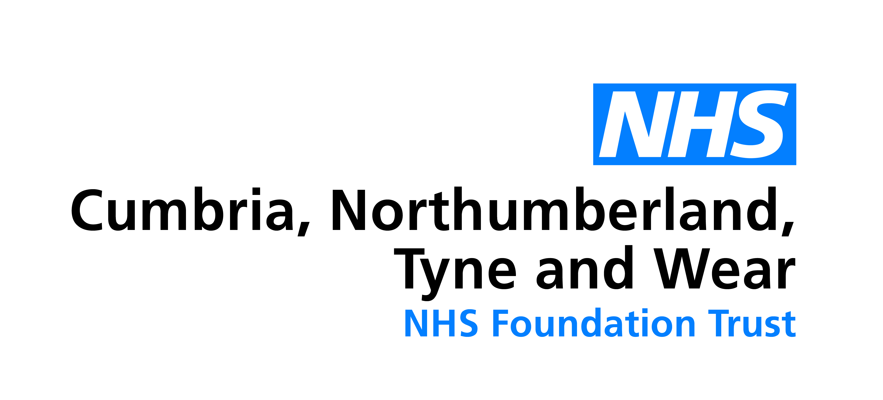

Community Acquired Brain Injury Service (CABIS)
Gateshead, Sunderland and South Tyneside

Information for referrers

About the service
The Community Acquired Brain Injury Service (CABIS) covers Gateshead, Sunderland and South Tyneside localities.

We provide an accessible, responsive, evidence based, specialist multidisciplinary service for people with an Acquired Brain Injury (ABI). An acquired brain injury includes traumatic brain injury (mild, moderate, and severe), anoxia/hypoxia (damage caused by a lack of oxygen to the brain), infections (meningitis, encephalitis etc.).

We offer short term, goal directed, community-based rehabilitation, with the intention of maximising independence and quality of life. We also offer dedicated carer support and vocational rehabilitation.

CABIS consists of a full multidisciplinary team including Neuropsychology, Occupational Therapy, Nursing, Physiotherapy, Speech and Language Therapy, Headway, and a Vocational Coordinator.

Where someone has complex comorbid needs, CABIS aims to work with multiple agencies to ensure a joined-up, person-centred approach to treatment.

How to refer
CABIS operate an open referral system and take referrals by letter, phone, email.
Referrals are accepted from professionals, service users, family members / friends (with service user consent).

We operate a single point of access, with a qualified member of staff on duty each day. This ensures all referrals are processed quickly and initial contact made.

A senior clinician is available to discuss potential referrals, provide ABI consultation and signposting.

Referral criteria
- Individuals over 16+ years,
- GP in commissioned locality,
- ABI primary presenting issue.

CABIS is not commissioned to take stroke cases or progressive conditions (for example, dementia, cancer, alcohol related brain damage).

If you know someone with a brain injury, in Gateshead, Sunderland, or South Tyneside, get in touch!

Telephone: (0191) 5665650
Email: CabisTeam@cntw.nhs.uk

Address: CABIS, Monkwearmouth Hospital, Newcastle Road, Sunderland, SR5 1NB

What if I have a comment, suggestion, compliment or complaint about the service?
If you want to make a comment, suggestion, compliment or complaint you can talk to the people directly involved in your care or you can complete a feedback form.
- Feedback forms are available from Trust staff
- Complaints Department Tel: 0191 245 6672
- You can complete a feedback form electronically by visiting the Trust Website www.cntw.nhs.uk (click on the ‘Contact Us’ tab)
- Speak to a Care Manager

Contact details
Sunderland and Gateshead Community Acquired Brain Injury Service (CABIS)

Telephone: 0191 5665650
Fax: 0191 5665651
Email: CabisTeam@cntw.nhs.uk

Monkwearmouth Hospital, Newcastle Road, Sunderland, SR5 1NB

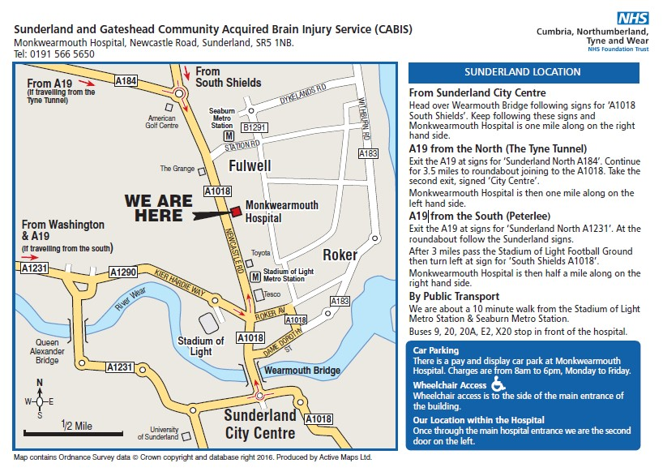

Gateshead Health Centre, Prince Consort Road, Gateshead, NE8 1NB
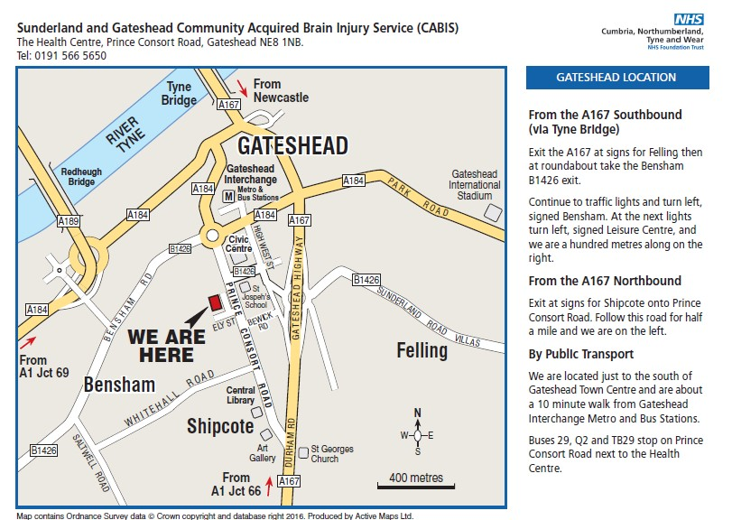

2024 Copyright, Cumbria, Northumberland, Tyne and Wear NHS Foundation Trust www.cntw.nhs.uk

Review date: April 2025

